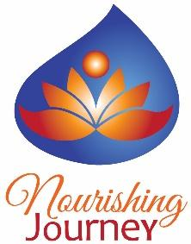
Jacob Palmer

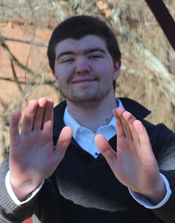
Expertise
Usui Reiki Master/Teacher, Animal Healer, Intuitive, Holistic Metamorphosis Practitioner, Galactic Light Councilate, Spiritual Animal Activator, Christed Consciousness Healing Founder, Empowered Aura White Dragon Energy Healing, Arcturian, Andromedan, Lyran, Sirian, Lionsgate, and Pleiadian Tuning

Introduction
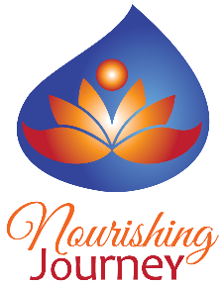
I have begun my journey as a young adult doing the greatest work I can imagine, and that is being a healer. It had all started while I was still in Heaven, before I was born, when I remember being told that I was to be a healer and to ascend along this path. I have spent my whole life getting through my own diagnosis of Autism and finding a future for me in a way that my purpose is put into realization. I have always kept myself moving deeper and deeper into the positive “vortexes”, or dimensions, and learning more about my own spirituality and purpose. Now, I have finally seeked it out and retrieved my inner empowerment and I would like to help bring your empowerment into view. If you want to know what title I own in Nourishing Journey, I may be one of the Staff, but I am also Inspirer for Nourishing Journey to run. I was also the one to allow the Nourishing Journey’s Owner to bring foreth the company at the birth of the company.
As time goes by, I have made enhancements to my healing ability and I was able to decrease my extremity of severe Autism symptoms. And now, I do group healings, one-on-one healing sessions, and even healing with animals and/or people through something called telepathy healing or distant healing. Here are a few fun-facts about me that I would want to share: I always wished that the entire world would be inclined to send healing to each other, creating peace, not violence. And, I have always had a deep respect for ancient traditions and beliefs. I have a very interesting view on the Power of Mythics, such as Dragons, Unicorns, Faeries, Direwolves, and so much more.
In my own future, I am learning to become a healer for the Earth, the Starseeds, the Space, the Time itself, and many more yet to come. I have dedicated my entire life to help heal what has been stuck with us for ages, sending Spiritual Guidance, Meditations, Energy Healing, and Violet Flames to help us move to Enlightenment. If you wish to understand me a little further, I have a website you can go to that is on here, a FaceBook Profile and Group, and I am at Nourishing Journey staying LIVE with you all. I am sending you all LOVE, LIGHT, PEACE, HAPPINESS, JOY, PRIDE, and FORGIVENESS, if needed. I wish you a wondrous time, Loves. Spread your Wings, your Love, your Light, your Peace, and anything that also has great meaning to it in a Positive Density, and let it shine at its fullest. Forgive anything that was of your old self and send pride to the new things that help uplift for who you bloom to be. Give Happiness and Joy to those who do not know it or just need it in their life, and you will then not just uplift yourself, but others as well.

Services offered
- Energy Healing – Usui Reiki, Holistic Metamorphosis, and Self-Attuned Healing
- Animal Healing – Healing Animals near and distant
- Group Healing – Healing a group of attendants inside an event
- Galactic Light Council and Activation – Both Personal Intuition and Class
- Christed Consciousness – A new modality I am Introducing
- Spiritual Animal Activation – See alignment with our own Spirit, Angelic Guide, and/or our Physical Traits that empower us in Positive Energy

make an appointment
Email address: info@nourishing-journey.com
Phone: 410-992-3001
Website: www.jacobdpalmer.com

